Safety Guidelines

Vehicle Procession
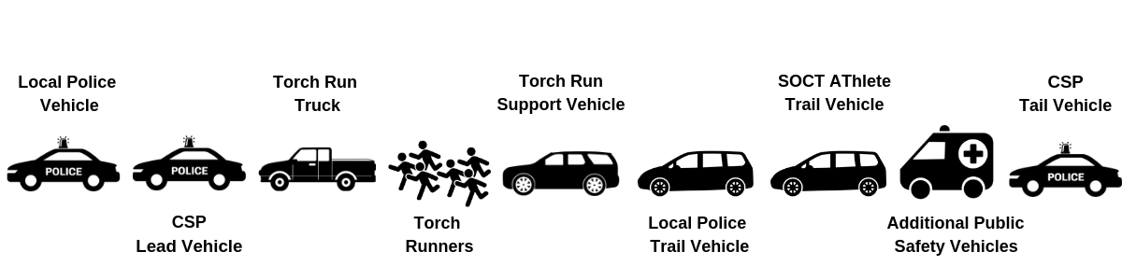
Please adhere to the following vehicle procession to ensure runner safety. Contact your Leg Coordinator with any questions about where your department vehicles should be placed or any concerns you have.

The runner’s safety is of the utmost importance during the run. Please watch for tired runners and direct them off the running surface or into a trail vehicle. The pace must be maintained at 11 minutes per mile.

- No children or children in strollers will be allowed to run NO EXCEPTIONS!
- No participants will be allowed to use roller blades or bicycles. Only Law Enforcement on bicycle patrol assisting in the safety of the run will be allowed.
- Runners must maintain an eleven (11) minute mile pace to ensure the proper coordination and timing of the Torch Run. Walkers cannot be accommodated during the run.
- If tired and unable to maintain pace runners must move off the roadway onto the sideway or similar surface.
- Runners can complete the run but must do so out of harm’s way. Motorcade will continue maintaining the pace.
- Tired runners will not be allowed to ride on the support vehicle (pick-up truck w/ Torch supplies etc.) but must get into a trail vehicle provided by the local department.
- Runners must never run ahead of the support vehicle (pick-up truck) nor should they fall behind the trail vehicle (CSP vehicle).
- NO ALCOHOL or intoxicated persons will be allowed to be part of the Torch Run.

Anyone NOT abiding by these rules will be asked to leave the run.

Torch Guidelines
The torch wick enclosed is made from fiberglass. This allows the frame to burn brightly and more efficiently than most torches. The tape at top and bottom helps to keep the wick from fraying and can be left on. Each wick will burn approximately 45 minutes when completely saturated with fuel.
The fuel chalice of the torch needs to be hand tightened only and it suggested you turn it back off ½ turn. Excessive force in tightening could cause the chalice to lodge and open. It could also damage the screw on the torch handle.

The burning time for the torch may vary due to usage and weather conditions. The recommended burning time for best results is 30 to 45 minutes before re-soaking the wick.

Instructions
- Use only lamp oil, i.e., “Coleman fuel”. Read all labels and work in a well-ventilated area away from heat and flame.
- Unscrew the wick assembly and remove from torch bowl. Place the wick into the plastic container provided. Add enough fuel, approximately 10 oz. to full saturate wick.
- When ready for use, remove wick assembly from plastic container and install wick into torch bowl. Do not force parts or over-tighten wick assembly. Keep threads clean and lubricated with petroleum jelly to avoid jamming.
- Ignite torch using a match or lighter.
- Always hold torch by handle away from clothing, hair and other combustibles.
- To extinguish, place the metal snuff cup over flame. The snuff cup should be accessible at ALL TIMES.
- Allow torch to cool before handling.
- Remove wick from torch and let dry thoroughly before placing torch in case for storage.

Warnings
- Always keep the flame away from hair, clothing and other combustibles.
- Never pour fuel directly into torch bowl. Overfilling can result in spillage and potential damage to person and property. Always use the plastic fuel contained provided.
- Read and follow all fuel warnings on labels.
- Keep torch and fuel away from children.
- Always check for proper ventilation when preparing, lighting and carrying the torch.
- Make sure the torch is completely extinguished and cooled before placing in case.
- Always remove wick from torch and let it dry thoroughly before storage.

Crisis Intervention Plan

The following is the Crisis Intervention Plan for any emergency during a torch run event for Special Olympics Connecticut. Representatives from LETR and the SOCT torch run liaison will determine if the situation is an emergency and, they will determine if a command center needs to be activated.

Crisis Intervention Team (CIT)

Determines if there is a true crisis
Jackie Turro, State Torch Run Liaison Cell # (860) 912-5356
(Ret) Lt Tom Madera, Torch Run Director Cell # (203) 605-1582
Lt. Rob Didato, Torch Run Director Cell # (203) 996-3594
Lt. Tim Bernier, Asst. Torch Run Director Cell # (203) 213-1577

Active Crisis Management Team
Implement crisis management / communications plan)
Jackie Turro, State Torch Run Liaison Cell # (860) 912-5356
(Ret) Lt Tom Madera, Torch Run Director Cell # (203) 605-1582
Lt. Rob Didato, Torch Run Director Cell # (203) 996-3594
Lt. Tim Bernier, Asst. Director of the Torch Run Cell # (203) 213-1577
Debbie Horne, Director of Communications Cell # (203) 889-6002
Beau Doherty, President Cell # (203) 640-1632
Mike Mason, Sr. VP / CFO Cell # (860) 307-6638
SOCT Emergency # (203) 230-1201 x 275

Actions
Contact emergency and police services immediately.
Contact crisis intervention team starting with:
- Torch Run Liaison, Jackie Turro (860) 912-5356

If you cannot reach Jackie follow
- Co-Torch Run Director – Tom Madera (203) 605-1582
- Co-Torch Run Director – Rob Didato (203) 996-3594
- Assistant Torch Run Director – Tim Bernier (203) 213-1577

If a situation is deemed a potential emergency, an immediate meeting will be called with the Crisis Intervention Team (CIT) to activate command center and dispatch resources.

On Scene Operations Coordinator
- Evaluate severity
- Determine event level criteria (refer to Addendum)
- Determine actions to respond
- Determine need for other staff and resources

Incident Commander
- Establish location for command center in consultation with all parties
- Obtain continuous updates from Operations Coordinator
- Brief all leaders on current situation
- Determine corrective actions as needed
- Exchange frequent updates with crisis management team as needed
- Ensure no statements are released unless issued by command staff at command center

LETR Event Coordinator
- Continues with existing event
- Continue to brief Incident Commander on the status of the event
- Inform the Command Center if the media is at any events and a PIO is needed.

Public Information Officer
- Determine affected PIO’s and notify
- Gather information related to incident
- Draft statement and have approved by CIT
- Determine if PIO’s need to have personal at event locations

In collaboration with LETR, LETR designated Public Information Officer and Special Olympics Connecticut, one statement is created, it will be determined who gives statement.

EVENT LEVEL CRITERIA

Level I Monitor
- No immediate danger or emergency exists, but the potential is present
- A minor incident occurs that appears to be a short duration
- The situation is limited in scope and can be managed by the appropriate administration

Level II Standby
- The potential danger is real; key personnel should be prepared to react
- The situation has the potential for expanding beyond a limited area
- The situation may continue for an extended duration
- Additional outside resources are needed

Level III Emergency
- Personnel are in danger; facilities are at risk
- Immediate action is necessary
- The incident is off property but close enough to affect a facility or involves students and personnel
- The situation requires the coordination of resources and/or coordination with outside agencies

